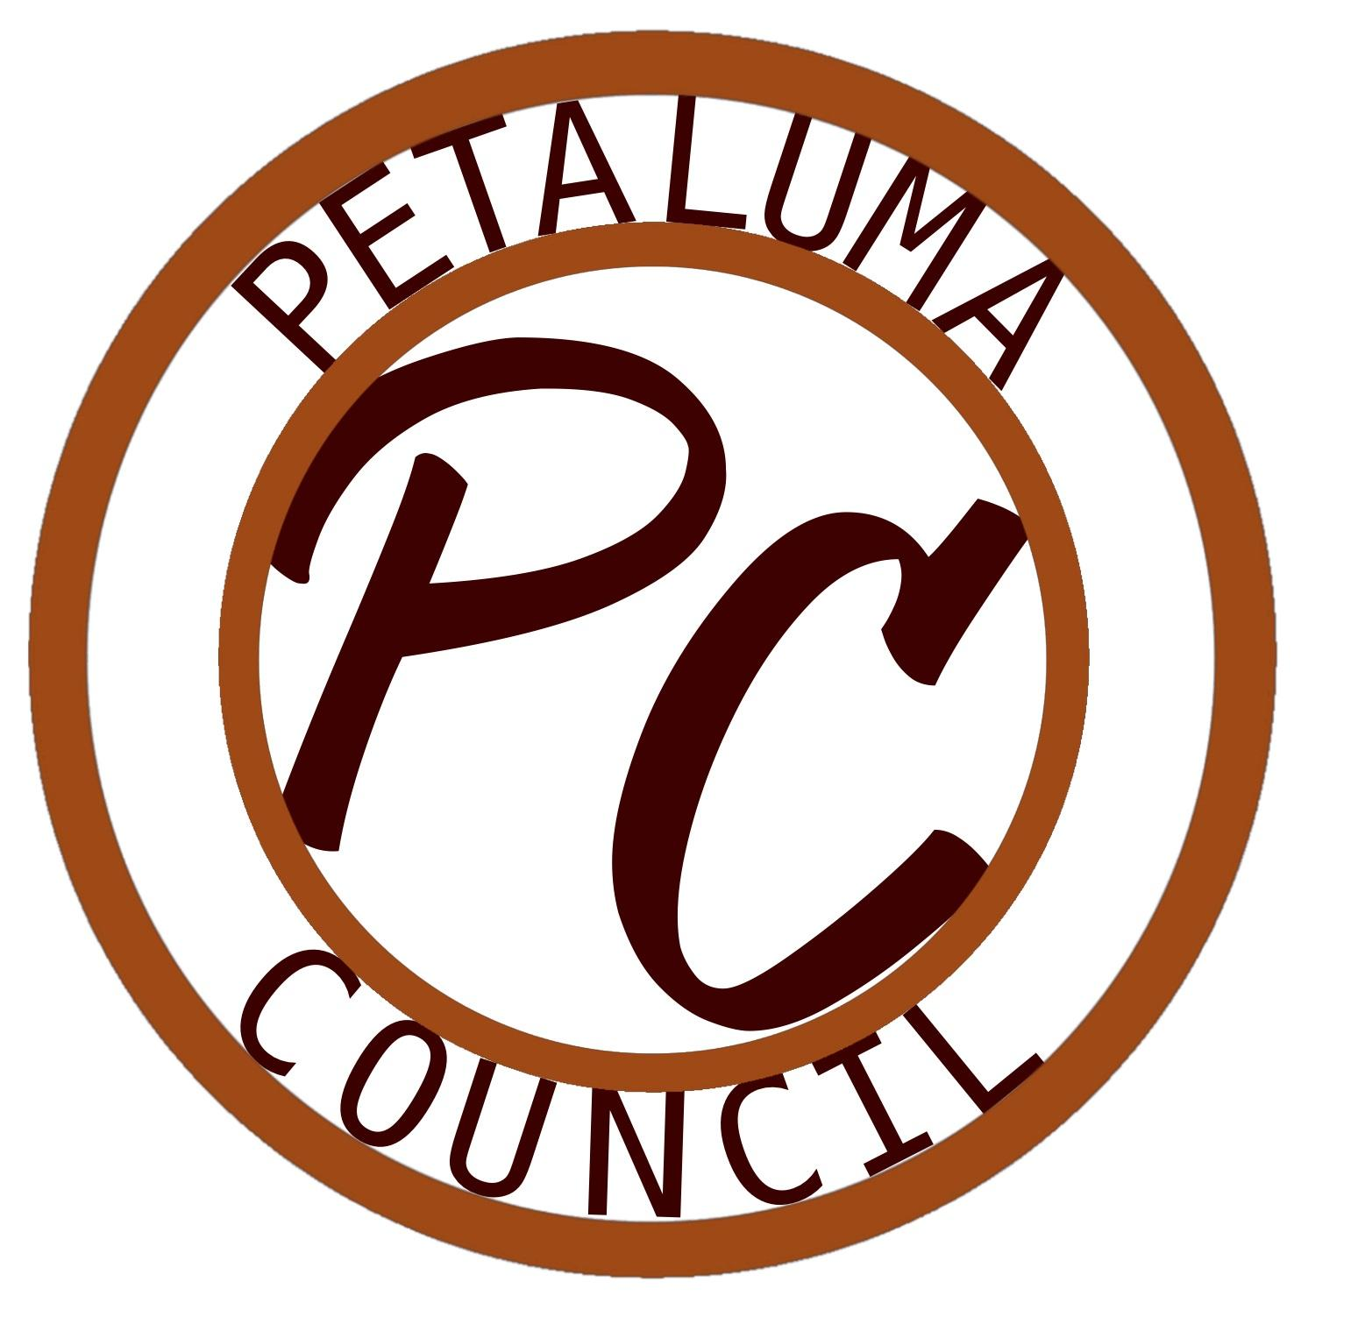 | PETALUMA COUNCIL (PC) | SPRING 2025  SPECIAL MEETING: Wednesday 4:15 PM - 5:15 PM  DATE: March 26th, 2025 | AGENDA #19
MEETING LOCATION
ADDRESS: 680 Sonoma Mountain Parkway, Petaluma, CA 94954
DISTRICT: Sonoma County Junior College District COLLEGE: Santa Rosa Junior College (SRJC)
CAMPUS: Petaluma BUILDING: Mike Smith Hall ROOM: #101
ZOOM: https://santarosa-edu.zoom.us/j/88516419729

ACCESSIBILITY/ACCOMMODATIONS
- AGENDAS & INFORMATION: https://petaluma.santarosa.edu/petaluma-council
- CONTACT: Student Life & Cultural Programs Office PHONE: (707) 527-4424

ADVISORS
- ADVISOR | Corrina Wells EMAIL: cwells@santarosa.edu OFFICE PHONE: (707) 522-2602
- FINANCE ADVISOR | Melissa Cowan EMAIL: clubaccounts@santarosa.edu OFFICE PHONE: (707) 524-1808

LAND ACKNOWLEDGEMENT
We acknowledge that we gather at Santa Rosa Junior College on the territorial traditional land of the Pomo People in Santa Rosa and the Coast Miwok People in Petaluma, past and present, and honor with gratitude the land itself and the people who have stewarded it throughout the generations. This land acknowledgement calls us to commit to continuing to learn how to be better stewards of the land we inhabit. We recognize that every member of the Santa Rosa Junior College community has benefitted, and continues to benefit, from the use and occupation of this land since the institution’s founding in 1918. Consistent with our values of community and diversity, we have a responsibility to acknowledge and make visible the colleges’ relationship to Native peoples. By offering this Land Acknowledgement, we affirm Indigenous sovereignty and will work to hold Santa Rosa Junior College more accountable to the needs of American Indian and Indigenous peoples.

- CALL TO ORDER & ROLL CALL:
START TIME:
OFFICER | NAME | ATTENDANCE
Vice President of Clubs - Petaluma | Amy Quintas
Vice President of Student Life - Petaluma | Matthew Coronado
Vice President of Marketing - Petaluma | Emily Marian
CLUB MEMBERSHIP | REPRESENTATIVE | ATTENDANCE
Baha'i Club
Fashion Club
Puente Club
ΣAπ
National Society of Leadership & Success

- APPROVAL OF AGENDA: https://petaluma.santarosa.edu/petaluma-council
The Petaluma Council (PC) shall review the current Agenda and the documented record of the previous meeting (known as ‘Minutes’) -making corrections as needed. Minutes can be found in the link above. Any changes to the Agenda will be noted in this section.
  - Current Meeting Agenda- #19

- PUBLIC COMMENTS (03 MINUTES PER SPEAKER, 10 MINUTES PER TOPIC)
Members of the Public may address the PC. Clarifying questions and comments may be entertained. The PC may restrict Public Comment to only speakers who wish to comment on items on the Agenda. [Ralph M. Brown Act (California Government Code §54950-54963, specifically §54954.3]

- REPORTS

- NEW BUSINESS
  - A motion may come forward to approve a Club Grant Proposal.
CLUB: Puente Club; FOR: Under the Sea Dance supplies and DJ ; AMOUNT: $850 ;
LINKED BELOW: https://drive.google.com/file/d/1ctd0gCt0LINGPwVWGR_FonUnSOl1ZMML/view?usp=sharing

- COMMUNICATIONS FROM THE FLOOR:
Announcements/future meeting requests/questions?
- ADJOURNMENT; END TIME:

